Chapter 12, Solution 45.

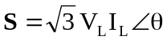

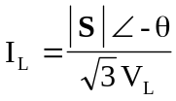, 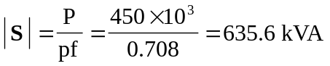

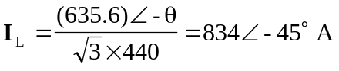

At the source,
